BSNL – Multiplay
Motive Client CD –
Technician Operations Guide

Table of Contents
Table of Contents 2
Revision History. 3
Introduction. 4
Plan Your Installation. 5
Refrain from the following During Installation. 8
Know The Screens. 9
Sample Error Screens and Hints For Recovery. 24

Revision History.
Date | Author | Version | Comments
26th Feb 2009 | Deepak Narayanan | 1.0 | Initial Draft
6th March 2009 | Abhijit Kumar | 1.1 | BSNL Feedback -  Points 6, 7 and 8 added in Plan Your Installation section.  Added “Enter HR ID” screen.  Added “Fail to Install” error screen with Retry option.  Added instruction in case of repetitive failure.  Added instruction to download and upgrade the supported software version.
15th October 2009 | Ravisha KS | 1.2 | Updated with new CPEs

Introduction.
This document is designed to familiarize the BSNL Technician with the Multiplay- Activation CD screens and the expected erroneous state which he may run into while using the application.

The purpose of the document is not to include or provide training to the technician but to familiarize him with various critical screens which may need his extra attention.

The document should be used as a live document and hence needs to be updated with the comments and inputs from the technicians with issues they encounter at the field.

To facilitate this all technicians are requested to provide feedback with screen shots that support the erroneous state of the application if they are not listed in the current document.

Technicians are always expected to follow this guide before they refrain to the war room for any installation issues.

Plan Your Installation.
- Ensure that the Modem/CPE is in factory reset state before you start with any installation. You can do a hard reset of the device by powering it on and clicking the reset button of the modem using a pointed tip.
- Ensure that the Modem/CPE to be used is not associated with any other customer. In case if you are reusing the device that was assigned to a customer, ensure the following
    - If this CPE was used by a customer who requested for a CPE swap, ensure that the first customer was provided with a new CPE and he has run the activation CD to get the device activated.
    - If the CPE was used by a customer who has terminated his DSL line, ensure that the termination order is placed and the work order is completed.
- Ensure that you have the PPPoE Username and the phone number including the STD code of the customer handy so that you can provide them correctly when prompted by the application.
    - Please ensure that you provide phone number along with the STD code when prompted for (For eg:- 08023644261)
- Analyze the customers system and decide on the type of connection to be made – For eg, USB, Ethernet or Ethernet and WiFi. We always recommend to use Ethernet or Ethernet and WiFi flow as these provide easy installation, faster access and less maintenance issues
- If the decision is to use USB flow, do not plug in the USB connection from the modem to the computer until it is prompted by the application. If you have already connected the Modem/CPE to the computer, please disconnect the device and restart the system before you proceed further with installation.
- The entire flow described above is ONLY for the Motive supported CPEs chosen in the portal by the Node Incharge.
- In case the user’s CD ROM drive is not working and technician is not able to run the CD, the SAM and SSM CD can be downloaded from http://motive.bsnl.co.in
- The table below mentions all the firmwares for the Motive supported CPEs.

TYPENAME | OUI | PRODUCTCLASS | SOFTWARE VERSION
BSNL Siemens Type1 - Mark 1 | 0085A0 | DSL gateway | V55.1.04.10
BSNL Siemens Type1 - Mark 2 | 0085A0 | DSL gateway | V55.1.04.01
BSNL Siemens Type1 - Mark 3 | 00085C | DSL gateway | V55.1.03.06
BSNL Siemens Type2 | 00085c | 96338W | V53.4.01.01_0940_081507-3.08L.BSNL_02.
BSNL Siemens Type2 | 00085c | 96338W | V53.4.01.01_1555_070607-3.08L.BSNL_02.
BSNL Siemens Type2 | 1.00E+40 | 96338W | V53.4.01.01
BSNL ZTE Type2 - Mark 1 | 0015eb | ZXDSL 531B | ZXDSL 531BIIV7.3.0f_D09_IN
BSNL ZTE Type2 - Mark 2 | 0019c6 | ZXDSL 531B | ZXDSL 531BIIV7.3.0g_D09_IN
BSNL ZTE Type1 - Mark 1 | 0015EB | ZXDSL 831AII | ZXDSL 831AIIV1.0.1i_D18_IN
BSNL ZTE Type1 - Mark 2 | 0019C6 | ZXDSL 831AII | ZXDSL 831AIIV1.0.1i_D18_IN
BSNL ITI Type2 | 001b57 | DNA-A211-I | 3.08.02.IB.02.01_1206_030308
BSNL SemIndia Type1 | 001b57 | ADSL2+ Modem/Router | 3.08.02.UB.01.14_1357_100807
 | 001b57 | ADSL2+ Modem/Router | 3.08.BSNL_02.01.02_tr64.
BSNL SemIndia Type2 | 001b57 | WA3002G4 | 1132_061507-3.08L.BSNL_02.
BSNL UTStarcom Type2 - Mark 2 | 001bda | WA3002G4 | 1132_061507-3.08L.BSNL_02.
BSNL UTStarcom Type1 - Mark 2 | 001bda | UT-300R2U | 1059_102108-3.08L.BSNL_02.
BSNL UTStarcom Type2 - Mark 3 | 001bda | WA-3002G4 | 3.12L.BSNL_01.A2pB023k.d20k_rc2
BSNL Siemens Type2 - Mark 3 | 00085c | 96338W2 | 3.12L.BSNL_01.A2pB023k.d20k_rc2
BSNL ZTE Type2 - Mark 3 | 00D09E | ZXDSL 531B | ZXDSL 531BIIV1.0.1a_D39_IN

- In case the software version of the CPE with the technician does not match with the above listed ones, the technician should download and upgrade the supported software version for the selected CPE from this webpage http://motive.bsnl.co.in

Refrain from the following During Installation.
- Do not remove the CD from the tray until the application installation is complete.
- Do not try to close the application using the ‘x’ button on the top right corner of the application window during the course of installation.
- Follow the instructions as instructed by the application and ensure that you proceed till the last page of the application which displays the user credentials along with his email username and password.
- Never press the cancel button when the application tries to do a software update from the server. Cancelling the updates would result in a havoc state whereby you may need to restart the installation from beginning to get the system in proper state.
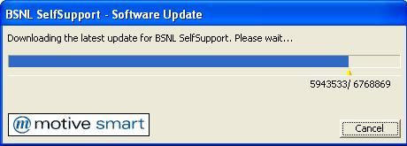

Know The Screens.
This section describes each critical screens in the application and describes the action items to take care while you are at this screen.

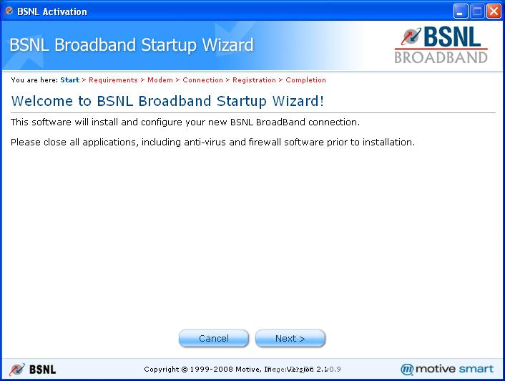
- Welcome Screen- This screen instructs you to close all the applications including antivirus and all firewall software’s. Please follow the instruction and make sure there are no proxy applications, VPN software and firewall activated and running on the system.

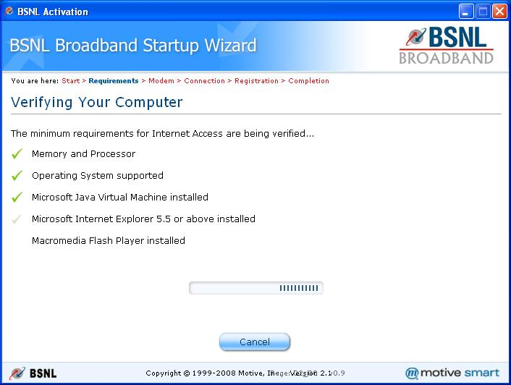
- Minimum Requirement Check :- This screen does the minimum requirement check for the system to support BSNL Broadband. The screen may take a while to complete the check and install required software. Please be patient and do not press cancel or the close button.
- Select Install Type :- This screen expects you to enter the type of installation to be followed. If selected “Technician Install” you will be prompted to enter the technician ID. If you are unaware of the same please click the link “Self Install” link and continue with the flow.

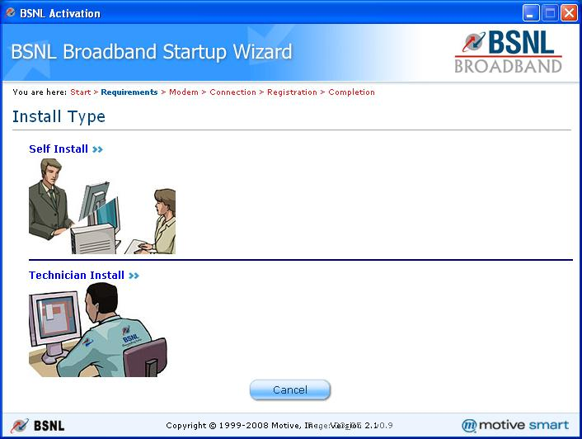

The screen below shows to enter the HR ID when “Technician Install” is chosen.

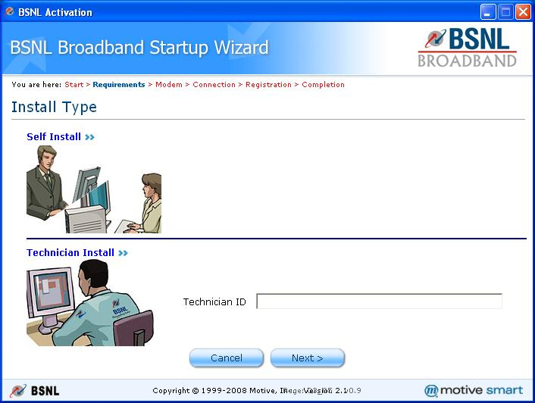

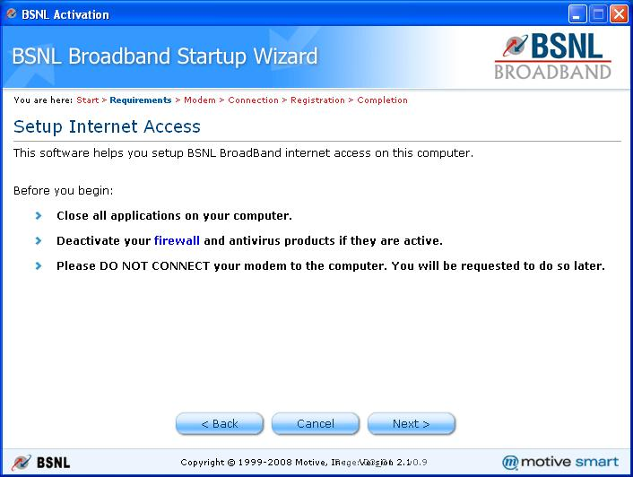
- Setup Internet Access Screen :- This screen reminds you to close all applications, firewall, and proxies if you haven’t done so before. You may click on the firewall link in this page to get a generic description on what firewalls are. As instructed on the screen please do not connect the modem to the computer until instructed by the application.

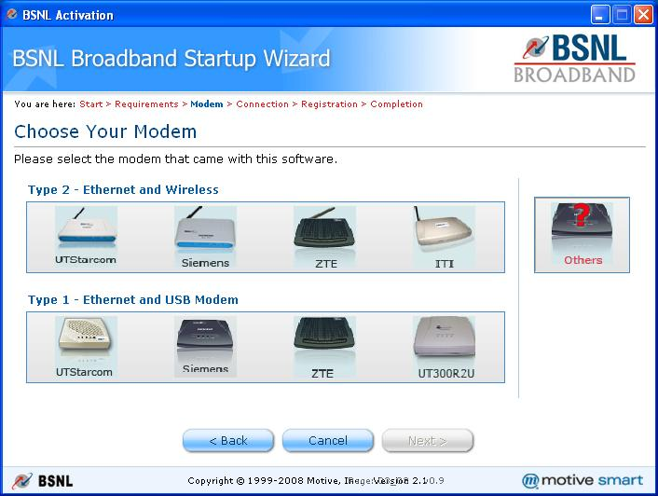
- Modem Selection Screen :- This screen allows you to select the correct modem for installation. Please select the correct modem from the picture and continue with installation. Please make sure that you do the right selection.
- Type of Connection :- This screen has two variants based on the modem detected by the application, one for the Ethernet and USB and one for Ethernet and Wireless type of modems.

  - The first variant (For USB and Ethernet Modems/CPE) prompts you to select from USB or Ethernet flow. Select Ethernet flow if the user has an Ethernet card (This is the recommended flow for this type of Modems/CPE). If not select the USB option.
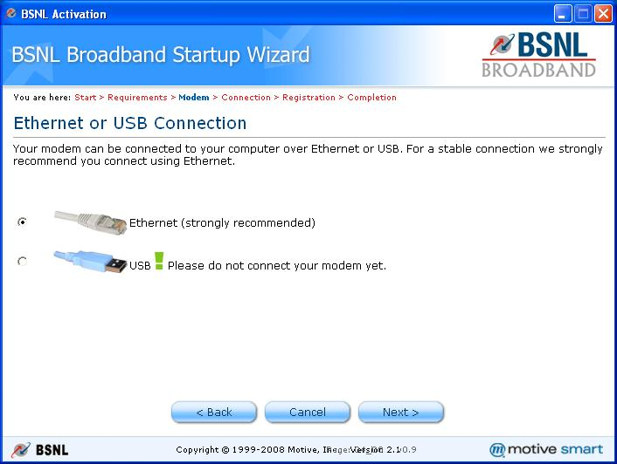

  - For the second variant (For Ethernet and Wireless Modems/CPE) select the Wireless option if the computer you are installing has a active wireless card with proper driver installation. The application does not install the driver for the wireless card during installation. Else select the Ethernet flow which is the default option.
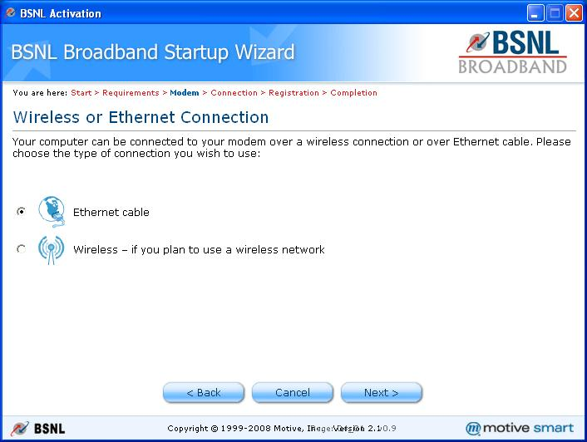

- User Registration Screen :- This screen prompts you to enter the PPPoE username and Subscriber Phone Number for the customer. Please ensure that you enter the complete PPPoE user name including the domain address of the subscriber. Eg:- The data in this filed can be rajaram2009@bsnl.in. The field Subscriber Phone Number expects you to enter the BSNL telephone number for which the broad band connection is applied for. Ensure that you enter the telephone number including the STD code. Eg:- The data in this field can be 08023644261
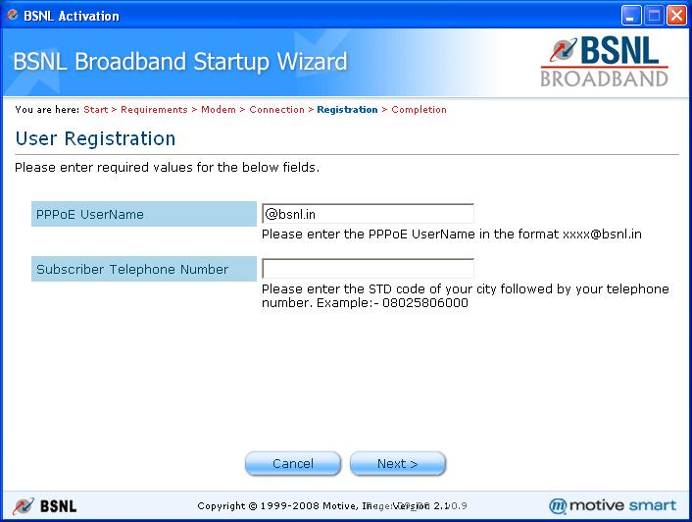

- Email Configuration Completed :- This screen is displayed after successful configuration of the email client (Outlook Express if present) on the computer.
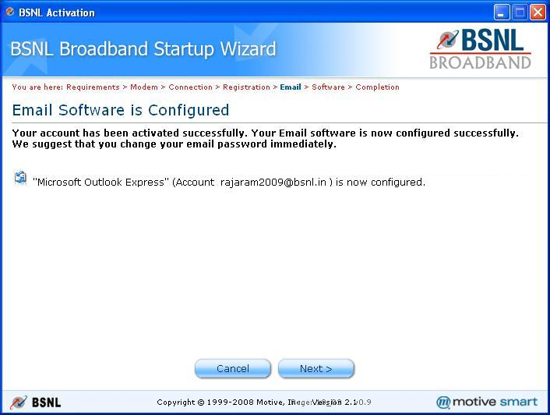

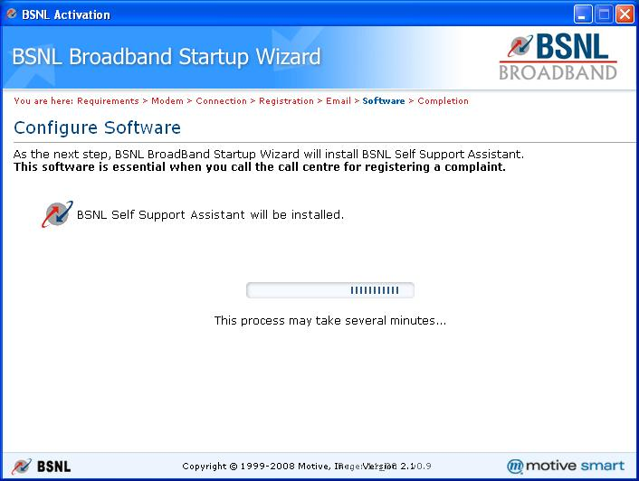
- Configure Software Screen :- This screen is displayed when the workflow installs the BSNL Self Care Application. This is a mandatory software which is required for the Customer Service representative to analyze and fix the issue for the customer during support calls. Please ensure that this software is getting installed on the customer machine.
- Configure Wireless Option Screen :- This screen is only displayed when the application detects that there is a supported wireless card installed on the customers computer and is enabled. Select the default option to install the wireless management software and configure the modem for wireless connectivity. If the customer does not want to configure the wireless option select the option “No I will configure the ……” In this page and continue with the workflow.

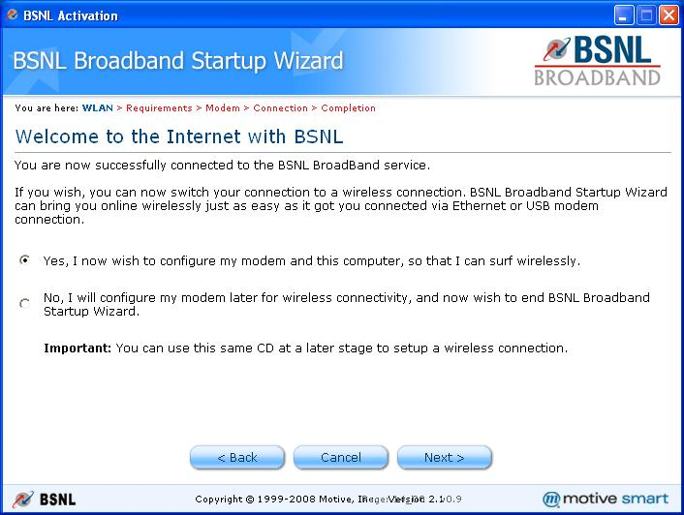

- Wireless Network Data Screen :- This screen is only displayed once the wireless configuration are successful on the modem. Please note down the SSID and WEPKey displayed in this page for future use.
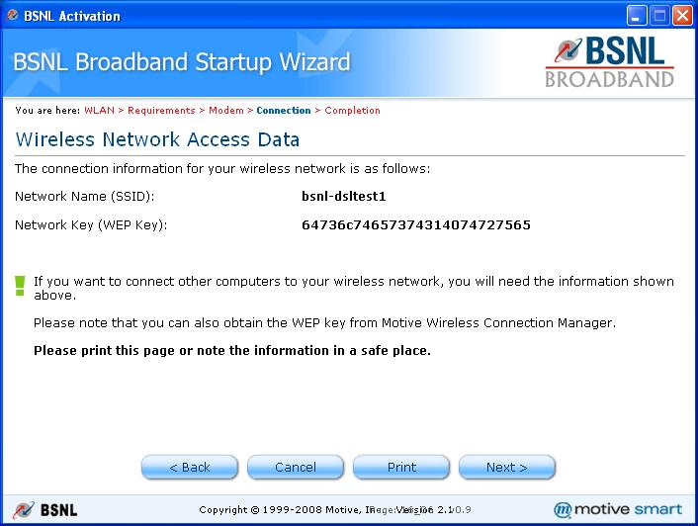

- Remove Ethernet Cable Screen :- This screen is displayed once the computer and the modem is setup and ready for a wireless connection. Ensure that you follow the steps as stated in the screen to ensure proper wireless connectivity.
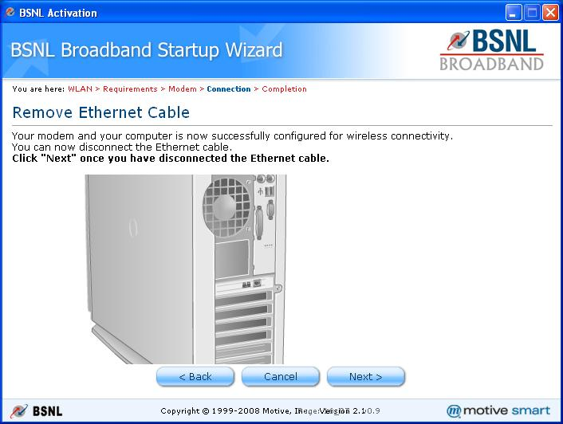

- Installation Complete Screen :- This screen is displayed after the installation is completed on the customer machine. Please note down the credentials/details displayed on this page and provide it to the customer for future use. You can also copy and paste the details to a text file on the customer’s machine. Press finish button to complete the installation. Remove the CD from the drive only after the application exits.
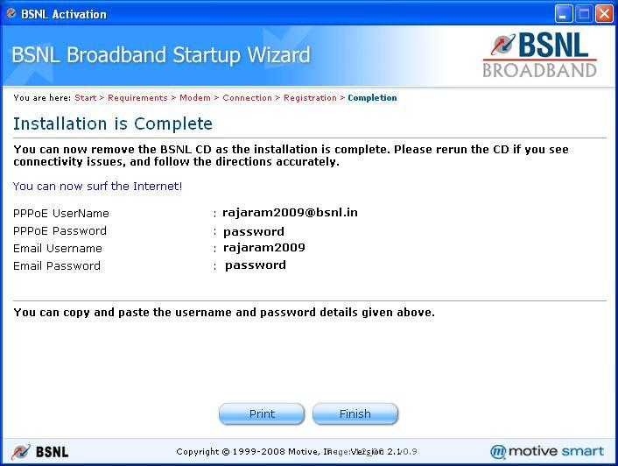

Sample Error Screens and Hints For Recovery.
- Modem Not Detected :- This screen is displayed in the following scenarios.
  - You have not followed the instructions as per the animations in the previous screen to connect the modem to the computer and power on the modem.
Hint :- Re check the connectivity and power cables and click on Next button.
  - The Modem/CPE which you are using is not supported by the application. You will encounter this issue only if you are using a CD which is not shipped with this modem.
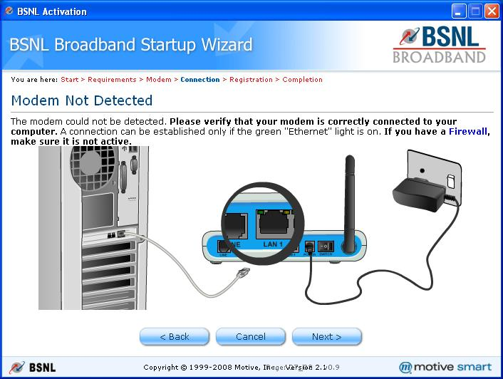
Hint :-Exit from the application and use the CD in the pack of this Modem/CPE.

- Failed To Connect To The Internet Screen :- This screen is displayed in the following scenarios.
  - You have not followed the instructions as per the animations in the previous screen to connect the filter to the phone jack and the DSL line to the modem.
Hint :- Re check the connectivity and click on Next button.
  - Your telephone connection is still not wired for a Broad Band Connection.
Hint :- Please check the account provisioning, Wiring from your Last Mile and local wiring to enable DSL Broadband on your telephone line.
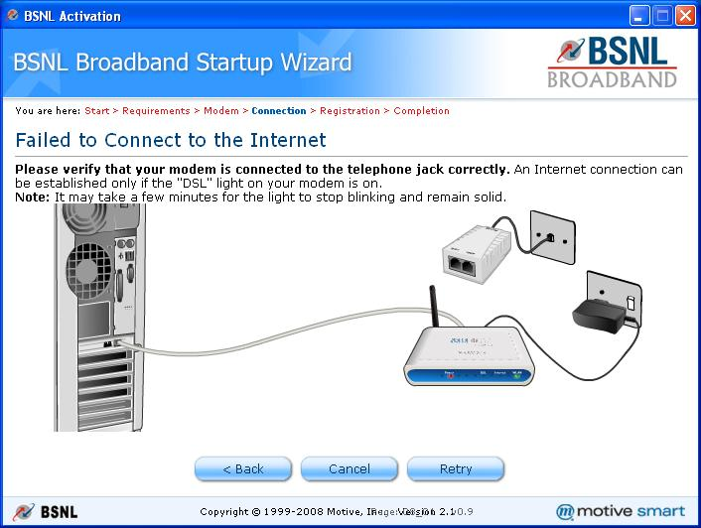

- Failed To Configure the ModemScreen :- This screen is displayed in multiple scenarios. Please read through the error message displayed in the page and follow the instructions. Please retry the operation a couple of times after correcting the previous error states if any to successfully configure the modem. Some of the scenarios which can cause this error state are
  - Work Order is not complete and hence provisioning of the subscriber connection is not complete.
Hint :-Complete the work order and retry activation
  - The PPPoE Username and Phone number provided in the previous screen is not correct.
Hint :-Click the Next button to provide correct values and Retry.
  - Server is too busy processing your request
Hint :-Wait for a few hours and retry activation.
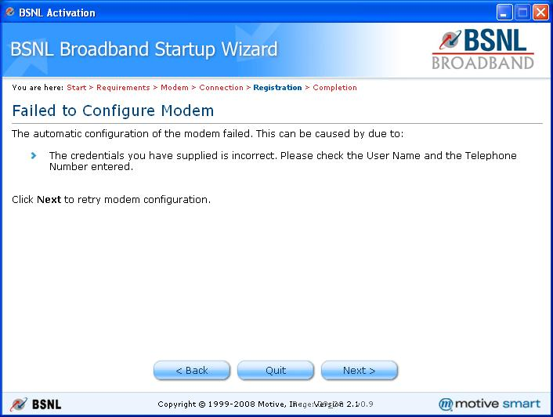

- Failed to Connect to BSNL Broadband Screen: This screen is displayed in multiple scenarios. The possible reasons for same are listed here in below shown screen. This screen has the option to “Retry” the setup flow.
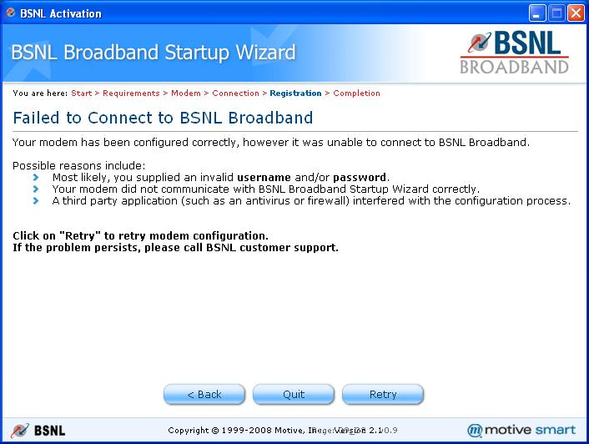

- In case of repetitive setup failure, the technician has to treat the CPE as a Motive unsupported one. He has to manually activate the CPE and manually trigger the billing for the CPE.
- The alternative option in case of repetitive failure is pre-provision the CPE (enter PPPOE user name and password in CPEs home page) and run the CD.
- Factory Resetting the CPE post CD activation: If the CPE is factory reset either through hard reset/soft reset post CD activation, technician is requested to wait for 2-3 minutes for browsing the internet. If it is not connected to internet in 2-3 minutes, it is recommended to reboot the modem once after 2-3 minutes post factory reset.

